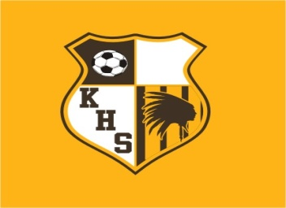
26TH ANNUAL KICKAPOO
CHIEFS SHOOTOUT – POOL PLAY
BROWN DIVISION 2016

SEPTEMBER 22ND THURSDAY – GRASS

5:00PM KICKAPOO VS SMITH COTTON
7:00PM GLENDALE VS CATHOLIC

SEPTEMBER 23RD FRIDAY -- TURF

5:00PM SACRED HEART VS KICKAPOO
7:00PM SMITH-COTTON VS JEFFERSON CITY

SEPTEMBER 24TH SATURDAY

11:30am GRASS SMITH COTTON vs SACRED HEART
11:30am TURF JEFFERSON CITY VS KICKAPOO
4:45pm TURF SACRED HEART vs JEFFERSON CITY

